7.34: From Eq. (7.15), 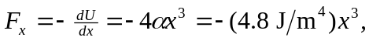 and so

